Call for artists
Participate in one of Phoenix Metro’s most impactful community events!

Create…an original art design on a large, crafted aluminum or petite steel butterfly. The Phoenix Rotary 100 club will supply the butterfly, a stipend, and a commission for your work.

Inspire…the artist in all of us.
Your butterfly will be on display to the public at the Shemer Art Center prior to the Take Flight 2024 Butterfly Social and Silent Auction.

Empower…people/families experiencing homelessness and youth art programs.
Proceeds from the butterflies will benefit community organizations dedicated to finding innovative solutions to the homeless epidemic and a wide variety of Rotary Community Service Projects.

The Cause and the Art Objects
Take Flight is a community service initiative led by Phoenix Rotary 100 to raise awareness about homelessness and butterflies represent transformation and people in situations that lead to homelessness or people currently experiencing homelessness are in extremely transformative periods of their lives. Our partnership with the Shemer Art Center will also support youth art programs and education.

The net revenue from TAKE FLIGHT benefits not only the homeless epidemic, but also a wide range of additional Rotary service projects and, in some cases, the entire city. These solutions have taken the form of education, drug rehabilitation, fighting food
insecurity, securing alternative housing, working with domestic abuse survivors and more. As a creative artist, your participation can help us be people of action in our community!

Take Flight 2024 will feature large and medium-sized aluminum butterflies, and petite steel butterflies this year. Participating artists will transform blank, aluminum (the medium and large objects) or steel (the petite objects) sculptures into original works of art. Each transformed sculpture will be displayed during the Art in the Garden event on March 23-24 (2024) held in the front lawn and sculpture area of the Shemer Art Center. Silent auction details to follow.

Important Dates:

Application and Design Concept due: Friday January 5, 2024
Notification of juror selections: Friday January 12, 2024
Artists’ Workshop – Pick up Butterflies: Thursday/Friday January 18-19, 2024
Completed butterfly art piece due: Friday March 1, 2024
Artist Compensation, Recognition, and Art Object Selection
Artists will be provided:
- *$250 stipend for materials for the large butterfly (one for raffle)
- *$150 for medium butterflies.
- *$75 for petite butterflies.
- Any costs incurred over these amounts should be considered a donation to Take Flight.
50% of the auction sale price for their art piece (capped at $500 for the large, $250 for medium and $100 for the petite). *STIPENDS AND SHARED PROFITS MAY REQUIRE THE ARTIST FILLS OUT A W-9 IN ADVANCE.
- Each artist who creates a LARGE or MEDIUM Butterfly will receive two free tickets to the Take Flight 2024 Social and Auction. The designer of a PETITE butterfly will receive one free ticket to the event. Tickets are per artist, not per number of pieces selected.
Note:
- The final “clear coat” will be provided by a partner of Phoenix Rotary 100.

Artists will be recognized:
- During the community exhibit on signage near their art piece and on associated printed materials.
- On the Rotary Club’s website. (Note that your brief biography will be included so it’s important!)
- Artists may be asked for an on-camera interview about their work. This could be used in the video presentation on the night of the auction. In any case, all artists will be recognized at the celebratory Take Flight Social and Butterfly Silent Auction.
- Artists are also encouraged to promote Take Flight & Art in the Garden on their individual Facebook pages and within the various artists groups to which they belong.

Applications:
As many as three design concepts per artist may be submitted using the application form at the Phoenix Rotary 100 website (www.rotary100.org). There you will find a TAKE FLIGHT 2024 link where you can enter your application data as well as downloadable templates for your designs. See: https://forms.gle/nx3CspjGAbc4P5jR9. Please note that all design concept images should be submitted in .jpg form. If you are not able to complete the application via the Web, please contact Rotary’s Artist Liaison who will provide you with a hard copy. If you are submitting a butterfly design, please be sure to designate your preference for size – large, medium, or petite.

Art Piece Selection:
These submissions will be reviewed by a Jury. If your application(s) is/are selected and you agree to participate, the signed application will serve as a “contract” for your work.

Community Exhibit
The larger art pieces will be placed on display at the Shemer Art Center during the Art in the Garden event on March 23-24. Petite butterflies will be displayed at various sponsoring locations in the community. The artist’s name and title of the art piece will be displayed near each work. In addition, a photograph of each completed piece, including the artist’s brief bio and inspiration description, will be available on the Rotary Club’s website and in other printed brochures associated with the event.

Design Guidelines
The audience for Take Flight & Art in the Garden will be the general public, including all ages and backgrounds. Designs deemed to be controversial due to: overtly religious, political, sexual in nature, insignia, or other material may not be accepted. Simply glued and “bedazzled” designs will not be accepted. Designs incorporating business logos or advertising will not be accepted. The Jury may reject any design that does not conform to these design guidelines.

The Sculpture Components
The butterfly sculpture components will be provided by the Rotary Club and should be picked up by each selected artist at the artists’ workshop location (to be provided later). There are multiple sizes of butterflies, so be sure to indicate on the application which one you have selected. Each sculpture component is made of aluminum (large and medium) or steel (petites). Large and medium butterflies will come on a metal stake with spikes. The Petites are considered “tabletop” but may also be mounted on a garden stake outside.

Important Information
Artists will produce their designs in their homes or studios. They can paint, sculpt, transform, or adorn (but not “bedazzle”) the art piece to complete their design, but the structural integrity of the piece must remain intact. All completed pieces will be protected for outdoor display; they will be finished with a clear coat from a designated partner. The art pieces will become the property of Take Flight until the final auction, when they will become the property of the highest bidder.

Concept Design Template

Artists should complete a concept design template (included with the application form) for each entry. Templates may not be enlarged greater than 8 ½ x 11” and must be submitted as a .jpg image. Make sure to create a thorough color design on both the top and bottom of the wings since this will be used by the Jury in the selection process. Once selected, the artist is bound to the design concept submitted. Any material deviations are subject to return to the artist for modifications. Please indicate if you want your design(s) to be considered for:
- the Petite Butterflies (as many as 20) - Petite: 12” Height, 12” Wingspan
- the Medium Butterflies (as many as 13) - Medium: 31" Height, 30" Wingspan
- the Large Butterflies (as many as 15) - Large: 50” Height, 48” Wingspan

Special Note
Take Flight is a charitable effort to raise funds for people experiencing homelessness and others in the community in need. Consequently, the successful sale of the pieces at auction relies on their appeal to bidders who may place them in their homes or outside in their gardens, or any outdoor location that should require minimal maintenance. Please keep this in mind when creating your piece.
Additional Guidelines
1. Take Flight is a community celebration of art where individuals are invited to touch and experience the pieces on public display. So, please keep durability and public safety in mind when designing.
2 Objects may be attached to the art pieces, but these objects must adhere to the guidelines noted above. Any attached objects must be attached in such a way that they cannot be easily removed. Designs using photos or skins will not be accepted.
3. The artist is responsible for any transportation from the workshops and to the designated clear coat partner. All transportation after clear coating is done by Rotary volunteers.
4. Artists may submit up to three designs, but each should be on a separate application form. All submitted designs will become the property of Take Flight.

2024 Timeline
Please be mindful of the schedule as you produce your piece.
January 5 Applications and design concepts due
January 12 Jury selection completed, and artists notified
January 18-19 Artists pickup butterflies! Artist Workshop: timeline, resources, marketing, monthly
check-ins with photos - W-9’s are due no later than pick up
January 22 Material stipend checks issued to artists (must have signed contract!)
Feb 1 to Mar 1 Monthly check-in from artists with photos/videos of metamorphosis
March 1 Completed butterflies due; artists drop off butterflies for clear coat

Thanks for your interest in TAKE FLIGHT 2024. I look forward to working with you!
Artist Liaison: Dan Capote 602-502-2103
Email: takeflight@rotary100.org

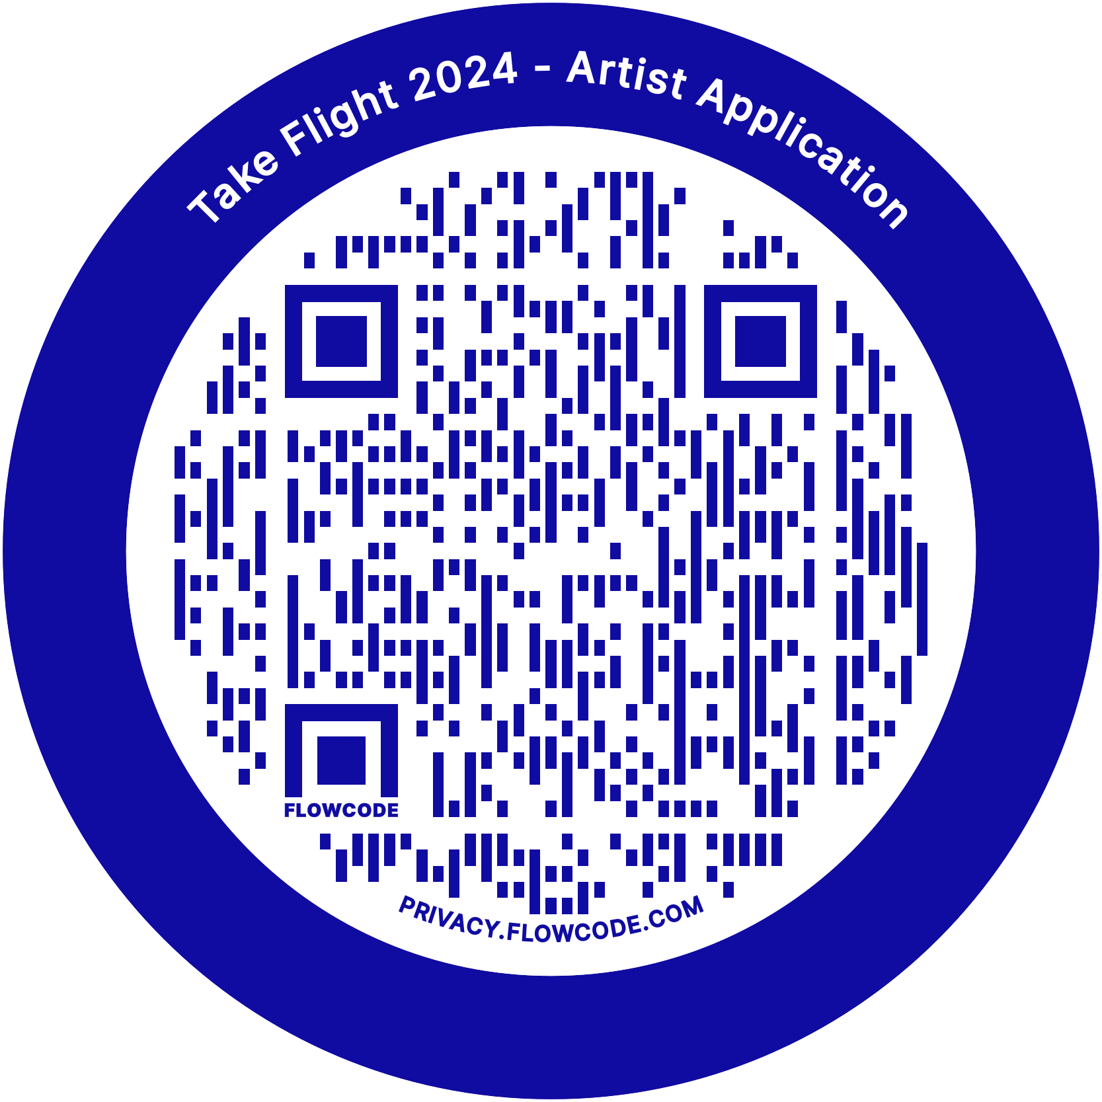

Artist Application Form

Deadline: Friday January 5, 2024

Last Name________________________________________ First Name _____________________________________ MI________

Address_______________________________________________________________________________ Apt#________________

City_____________________________________________________________ State______________ Zip_____________________

Phone (Home)__________________________________________ Phone (cell)__________________________________________

E-Mail______________________________________________ Primary Gallery affiliation (if any)___________________________

Name as it would appear on plaque and in publications____________________________________________________________

Proposed Title for Art Piece___________________________________________________________________________________

What was your inspiration? ___________________________________________________________________________________ ___________________________________________________________________________________________________________
___________________________________________________________________________________________________________
Why did you want to get involved in Take Flight? ___________________________________________________________________________________________________________ ___________________________________________________________________________________________________________
___________________________________________________________________________________________________________

Brief description of your proposed design and materials:
___________________________________________________________________________________________________________
___________________________________________________________________________________________________________
___________________________________________________________________________________________________________

Artist Checklist (make sure you include ALL requested materials):
□ Check butterfly size preference or dragonfly:
□ Willing to do any size □ Petite □ Large Butterfly □ Medium Butterfly
□ Read and understand all details as provided in Call for artists, Guidelines and Timeline
□ Completed Artist Application Form
□ Attach the completed concept design template (include color and in .jpg form) for the proposed art piece. No larger than 8.5" x 11"
□ Artist’s brief bio (150 word limit) outlining artistic experience, background (for publicity).
□ Photographs or other examples of past work – .jpg files.
□ Submit applications and concept designs via the Rotary website. Contact the Artist Liasion if you need help or must submit through hard copy materials.
□ Keep a copy of your Application Form and Concept Design template.
By signing this application, I agree to all terms as described in the attached Call for Artists, Guidelines and Timeline. I certify that all statements and design concepts are my own.
Note: Take Flight is not liable for any damaged, lost or incomplete submissions.

Signature___________________________________________________________________ Date___________________________

Please complete this application via: https://forms.gle/nx3CspjGAbc4P5jR9
Call or e-mail me if you have questions.
Artist Liaison: Dan Capote 602-502-2103
Email: takeflight@rotary100.org

PLEASE DUPLICATE FORMS AND TURN IN ONE PER ENTRY (.jpg) WITH APPLICATION
Large or Medium Butterfly Concept Design Template: Top view

Artist’s name: ________________________________________

Preferred size: Large___________ Medium_____________ Any (including petite) ________________

Large or Medium Butterfly Concept Design Template: Bottom view

PLEASE DUPLICATE FORMS AND TURN IN ONE (.jpg) PER ENTRY WITH APPLICATION

PLEASE DUPLICATE FORMS AND TURN IN ONE (.jpg) PER ENTRY WITH APPLICATION
Petite Butterfly Concept Design Template: Top view

Artist’s name: ________________________________________

Petite Butterfly Concept Design Template: Bottom view

PLEASE DUPLICATE FORMS AND TURN IN ONE (.jpg) PER ENTRY WITH APPLICATION

